**SignUP:** [**https://citria.org/sign-up**](https://citria.org/sign-up)

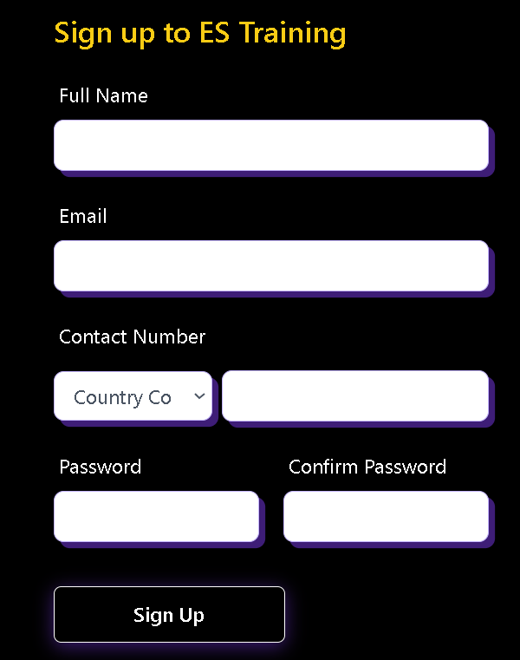

The SignUp component is a React component responsible for handling the sign-up functionality in a web application. Let's break down its key features and functionality.

1. State and Hooks:

The component uses React hooks like useState and useEffect to manage state and handle side effects, respectively.

State variables include loading, signInPopUp, openModal, formData, and formErrors.

2. Form Handling:

The handleChange function updates the formData state in response to user input.

Form validation is performed in the validateForm function, which checks for errors in the entered data.

3. Lifecycle and Navigation:

The useEffect hook is employed to check if the user is already authenticated (using a stored token) and redirects them to the appropriate page.

The useLocation hook helps in extracting the from path from the URL, which is used for redirection after successful sign-up.

4. API Interaction:

The handleSubmit function is triggered on form submission.

It validates the form, displays errors if any, and makes an asynchronous POST request to the server for user registration.

The response is used to display a modal (openModal) and navigate to the activation code page.

5. UI/UX and Styling:

The component is styled using Tailwind CSS, providing a clean and responsive design.

Conditional rendering of a loading spinner (<Spinner />) indicates ongoing operations.

6. Modal and Closing:

A modal is displayed for successful sign-up or to show an error.

Users can close the modal using the close button (IoCloseSharp).

The closeModel function is used for navigation after closing the modal.

7. External Components:

The component includes other components like GoogleSignIn and Spinner for specific functionalities.

8. Routing:

The useNavigate hook is used for programmatic navigation after successful actions.